Changes in HOME

- The Homepage, use a "Grid & Card" layout.
  - Text to add: "50+ Countries Represented | 500+ Global Applications | 10+ Strategic Partners.

- Add reviews from past events after this

- Update Our engagement section with the pictures of past events.

- All the buttons linked to the DIGITAL DIPLOMACY SUMMIT APPLICATION PAGE

- ADD GALLERY

- The new diplomacy conference will be moved to past events. Also add our last seminar in past event (intercultural communication in the modern world)
“Discover our events and explore both upcoming programs and past highlights.”
Remove dash, shows it is AI written

- Making sure all social media buttons are connected to the account

Changes in ABOUT
- ALL THE PICTURES ON THE WEBSITE SHOULD BE FROM PAST EVENTS NO INTERNET PICTURES (IF NEED MAKE A POSTER OUT OF IT TAKING HELP FROM DESIGNER)

- ABOUT SECTION IS VERY BORING ADD SOME CREATIVE ELEMENT TO IT MAYBE DIFFERENT STYLE RATHER THAN 3 DIFFERENT PARAGRAPHS
FOR EXAMPLE: The "Our Vision" Section: Instead of a simple text block, use three columns with high-quality icons representing:
  - Strategic Research 2. Diplomatic Training 3. Youth Leadership.

IDEA: we can add stats from past events write name of previous event then add no of participants, no of countries, etc that is how we can show past events too

EXAMPLE PAGE:

1. Visionary Header
- Headline: Bridging the Gap Between Youth Leadership and Global Governance.
- Subtitle: The Centre for Strategic Youth and Global Affairs (CSYGA) is an international think tank and leadership incubator dedicated to empowering the next generation of diplomatic leaders.

2. Our Mission (Use a Clean 2-Column Layout)
- The Mission: To provide young leaders with the strategic tools, diplomatic training, and institutional access required to navigate and influence the complexities of modern global affairs.
- The Vision: To build a sustainable global ecosystem where youth-driven diplomacy, ethical technology, and humanitarian action create a more secure and inclusive world.

3. Core Pillars (Icon-Based Grid)
- I. Youth-Driven Diplomacy: Creating high-level platforms for young professionals to engage directly with state actors and international organizations.
- II. Ethical Technology: Promoting the responsible use of digital tools and AI in peacebuilding and public discourse.
- III. Humanitarian Action: Strengthening the role of youth in crisis response, advocacy, and international cooperation.
- IV. Leadership Development: Equipping future policymakers with technical skills in negotiation, policy analysis, and strategic communication.

4. Why CSYGA? (The Authority Section)
- Proven Track Record: Our initiatives have engaged hundreds of participants from over 50 countries, creating a truly global network of emerging leaders.
- Institutional Access: Based in the diplomatic hub of Istanbul, we facilitate direct engagement with consulates, municipal governments, and international NGOs.
- Strategic Impact: We don't just host events; we produce policy recommendations and simulations that prepare youth for real-world diplomatic challenges.

5. Our Global Footprint (Key Metrics)
- 50+ Countries Represented
- 1000+ Network Members
- 10+ Institutional Partners (YTB, TUGVA, UDEF, and more)
- 20+ High-Level Diplomatic Simulations Conducted

6. Leadership & Governance (we will add later after we get advisors)
- Note for Developer: This section should feature professional headshots.
- Text: CSYGA is led by a board of experts in international relations, digital governance, and humanitarian diplomacy, supported by a global secretariat of passionate young professionals.

7. Institutional Partners (Logo Slider)
- Instruction: Display the grayscale logos of your partners here.
- Caption: Working in collaboration with leading governmental and non-governmental institutions to foster global youth empowerment.

Changes in DYNAMIC ENGAGEMENT

- Update all pictures, all buttons linked to the Apply for the digital diplomacy summit

- Our past events must be linked somehow with all the sub categories

- A dedicated section for the digital diplomacy conference
EXAMPLE

The "Digital Diplomacy Summit 2025

Crucial: On the Engagements page, there should be a large, dedicated banner for the upcoming May event.
- Text for the Banner:
  - Heading: Next Major Engagement: Digital Diplomacy Summit 2025
  - Dates: May 22 - 24, 2025 | Istanbul
  - Key Highlight: Includes official visits to international organizations and CITY TOUR .
  - Status: [Applications Open - Apply by March 10th]

Changes in Partner Section

- Till partners it is good. After that the cards of program collaboration etc is not good. We can make icons/posters using past event pictures to use it here.

- Become a partner section leads to connect with us in that section address is not aligned

- Where are all these emails going to? If someone is filling this(We can have discussion on this)

Changes in GET INVOLVED

- Same here the cards are boring and should be created with the pictures, also text is not aligned.
- Youth delegate program will be linked to the digital diplomacy page
- In becoming a mentor we will make a new form
- Remove the apply part in the bottom

NOW LAST EVENT PAGE!!

**************************************************************************************************
28 feb 2026


Why this log on tabs?

MAIN PAGE EDITINGS:

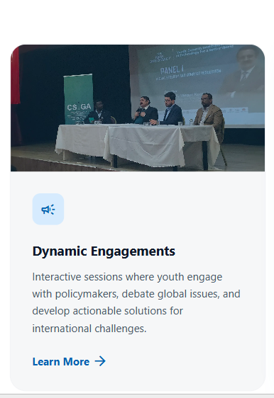

CHANGE PICTURE (NEW PIC SENT ON WHATSAPP)

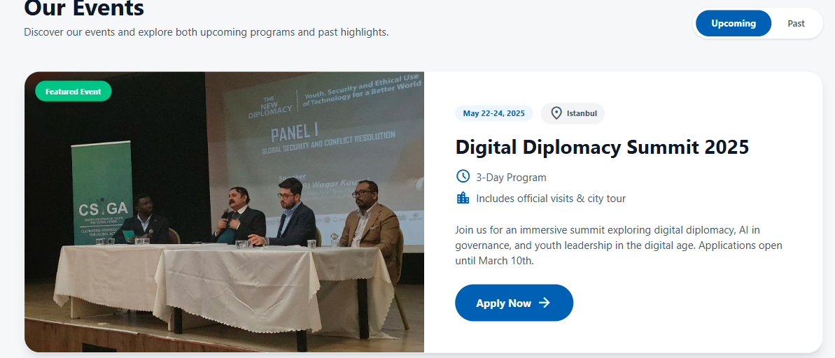

- Upload poster, (logo of digital diplomacy is missing from the whole website)
- Remove city tour word.
- Change dates

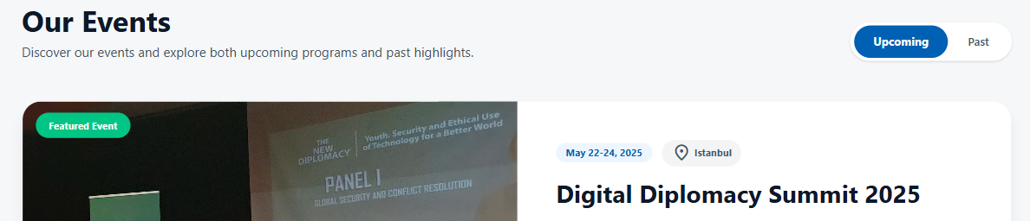

When click on digital diplomacy summit 2025. Event page should open.

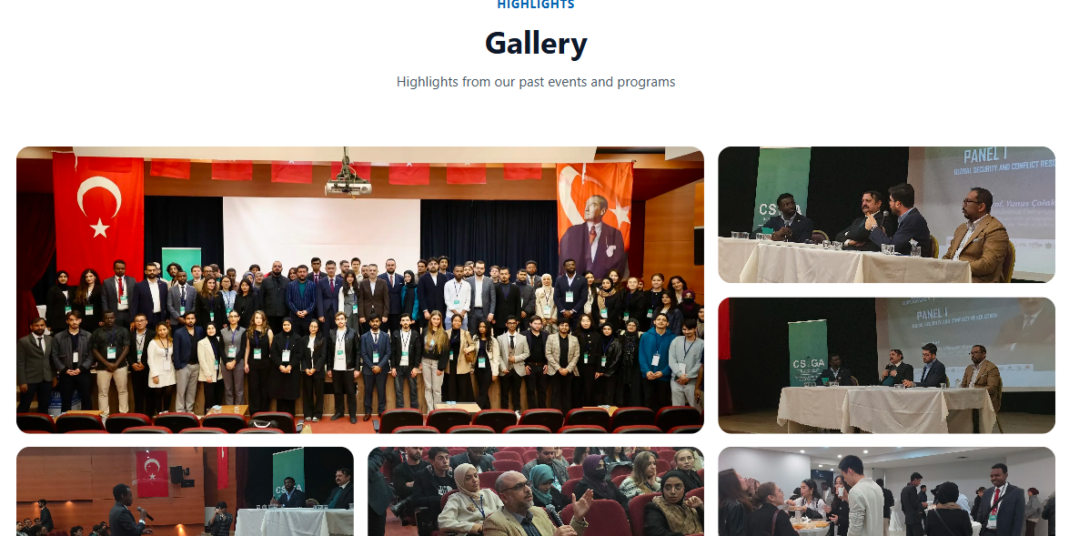

Please update this section
Same picture is twice, Only one event is highlighted, maybe you can add sliders)

ABOUT US EDITINGS:

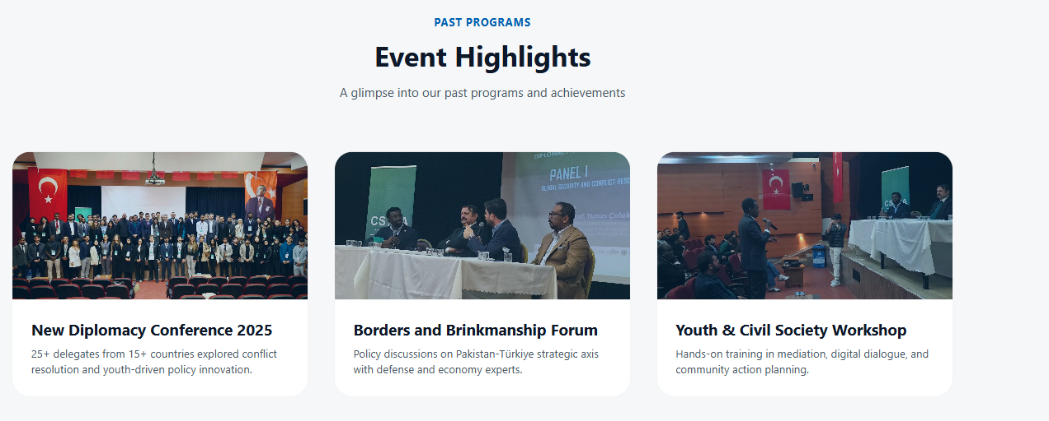

Please choose different events picture

OUR ENGAGEMENT EDITINGS:

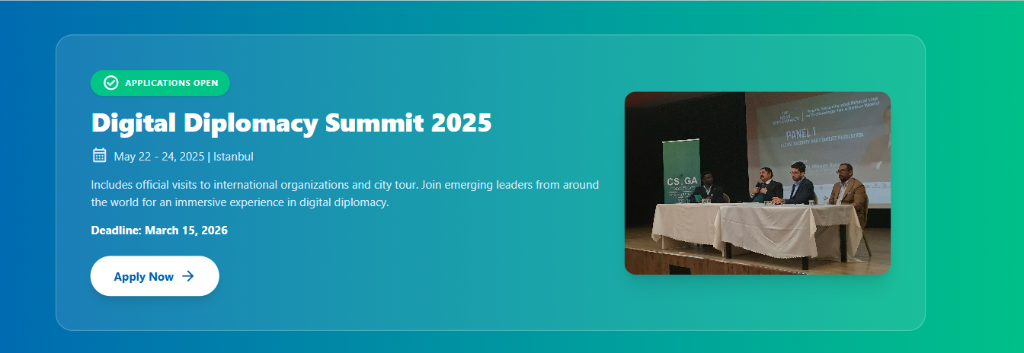

Update this accordingly.

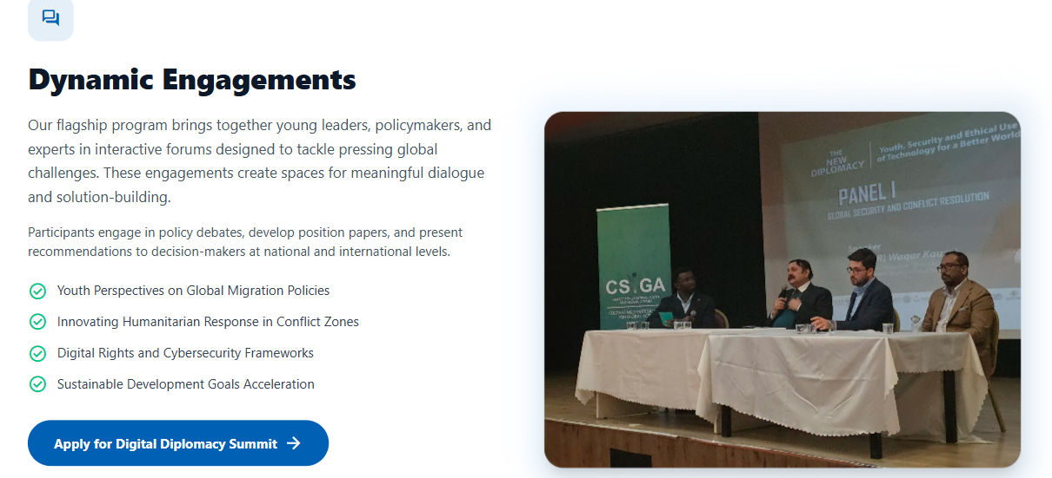

Remove this comment icon on tab,
Change of picture please.

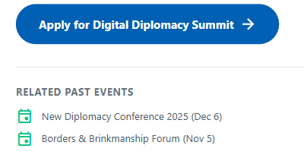

December 06 2025

November

